Please Pray with
Us!

* Pray for God’s glory to be spread through all the people groups of East Asia. 65% have never heard.

∗ Pray for God to be at work in hearts (2 Peter 3:9).

∗ Pray for our family to be growing in Him. We want our first witness to be our family.

∗ Pray for our walks with God to be strong and intimate.

∗ Pray for our financial support to be in order by August 1st.

∗ Pray for our marriage to be strong & glorifying to God.

∗ Pray for us to parent well and for our kids to know and love Jesus.

∗ Pray for our ministry situation as we will need to work outside of East Asia and yet equip the church there from afar.





Josh & Tammy Hunt

Temporary address:
9198 Venezia Plantation Dr.,
Orlando,FL 32829

Permanent address:
403 W. Main Street
Marengo, IA 52301

Cell: Josh 612-441-1249
Tammy- 612-441-1250

Email: josh.hunt@cru.org
tammy.hunt@cru.org

Unleashing the gospel Among the nations-
Josh & Tammy Hunt-
Jesus Film East Asia



Matthew 28: 19-20

“Go therefore and make disciples
of all the nations. . .”

“And this gospel. . . Will be
preached ... to all the nations
. .. And then the end will come.”

Matthew 24: 14

Unleashing the gospel Among the Nations

Perspective People Partnership
Training Churches to reach unreached cities and peoples

The Task Remaining

Throughout their 5000 year history, the people of East Asia have been antagonistic towards the gospel. In 1949 with the communist takeover, all religion was banned from East Asia. But in the last 25 years, there has been an unprecedented spiritual revival in East Asia.

Here’s the reality today:

· 1.5 billion people

· 65% have not heard the gospel

· An estimated 1 Fulltime Christian worker per 3 million people, very few for around 120 million Christians.

Here’s how our ministry with Jesus Film seeks to complete the task. Three strategies of Campus Crusade in East Asia work in partnership with each other and the local church in East Asia to fulfill the Great Commission. We seek to build leaders in the following ways.

Student Led: Campus movements are built to win, build and send laborers to the campus, the city, the country and the world, with students as the key players.

Leader Led: Via discipling Christians in various parts of society we seek to change people’s worldviews that they may be more open to Jesus and equip the local church for the work of Christ.

Church planting/Jesus Film outreach: We equip pastors and others to reach every person via many means like the Jesus Film and church planting strategies.
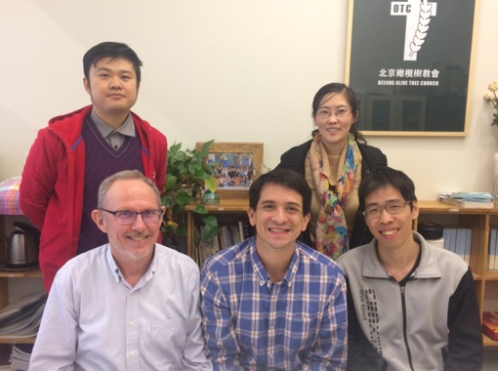
Our role in reaching the people of East Asia and the world is helping believers in our ministry and local churches we partner with to understand the true meaning of the Great Commission and mobilizing them into action to join in His plan. Matthew 28:18-20 tells us to make disciples of all nations, The word nations means ethnic people groups in Greek. East Asia alone has 500 ethnic people groups, who often do not relate to each other. Over 400 do not have a church in their heart language and have little access (if any) to the gospel.

Our strategy is simple: when a local body has understood the issue of reaching all peoples, we present a variety of challenges to help people meet new people groups and pray like crazy that the Lord not only uses it to reach people groups. Now, our work with Jesus Film tasks us to give these same churches training and resources to plant churches amongst these peoples.

Oak Tree Church is a great example of a church we have reached. Their pastor and wife have been active advocates of a mission class we have hosted at their church numerous times, the church actively recruits people to reach unreached people groups regularly and one of their staff has been freed up to be Josh’s right hand man in the East Asian church networks we equip.



We truly believe that God has called us to reach the nations for Christ, and our part is by being committed to a continue to minister to East Asia. We cannot do this on our own.

Our ministry is an extension of the local church It’s a privilege to serve with you. Like a man who needed to go down into the well to rescue one who’d fallen in. A man went in after the one who needed to be rescued, but others held the rope so he’d be able to rescue the one who’d fallen.

CCCI has no central funds for paying salaries. All CCCI staff raise the funds to cover all living & ministry expenses.

We invite you to partner with us in His work. You can give monthly & annually. We invite you to pray about giving prayerfully at $50, $75, $100 or some other amount per month. We need to see God provide $1800 monthly and $15,000 annually to continue fulltime service.

We are excited to partner with His Body in His work. You can send your first check to our temporary address. All gifts are tax deductible & should be made payable to CRU with our acct. number (0486125), on the memo line or given via EFT at give.cru.org and enter our account number (our names are hidden).

